
Namibia University Of Science And Technology
Faculty of computing and informatics

DSA521S – DATA STRUCTURES AND ALGORITHMS 1 GROUP MINI-PROJECT 2026
Mini Project Title
NUST Service Centre Simulation: Designing and Evaluating Data Structures and Algorithms

Group Members
NO. | Full Name | Student Number
1 | Nelca Maleka Zinga | 226046389
2 | Gizela S. A. Manuel | 226029069
3 | Ndasilwohenda Nandiinotya | 224080881
4 | Paulina salom | 226082830
5 | Shikongo Andreas Hafeni pombili | 226035271
6 | Tafadzwa Blazio Mutakiwa | 226029522

Windhoek,Namibia
September 2026
QUEUE

A Queue there are persente on everyday in the geral happen to look for a service that is bigger than the capacity of the system to serve to the students.Increasing the capacity of atendement many times is not possible because of limitantion physics ou economics . that’s why , a teory of the queue . The system use a queue to controle the ordem of atendement.
- Enqueue(Student):
IF rear == size – 1
PRINT "Queue is full"
ELSE IF front == -1 AND rear == -1
front = 0
rear = 0
queue[rear] = student
ELSE
rear = rear + 1
queue[rear] = student
ENDIF
- Dequeue():
IF front == -1 AND rear == -1:
DISPLAY "Queue is empty"
ELSE IF front == rear:
DISPLAY "Student removed: " + queue[front]
front = -1
rear = -1
ELSE
DISPLAY "Student removed: " + queue[front]
front = front + 1
ENDIF

- IsEmpty()
IF front == -1 OR front > rear
DISPLAY "Queue is empty"
ELSE
DISPLAY "Queue is not empty"
ENDIF

- Display Queue()
IF front == -1 AND rear == -1
DISPLAY "Queue is empty"
ELSE
FOR i from front TO rear
DISPLAY queue[i]
ENDFOR
- Peek():
IF rear == -1 PRINT
DISPLAY "Queue is empty"
ELSE
DISPLAY queue[front]

DIAGRAM
FRONT

MARIA
Student5
SIMON
NDAPEWA
TOMAS
Student6

REAR

Scrrenshot enqueue of 6 students

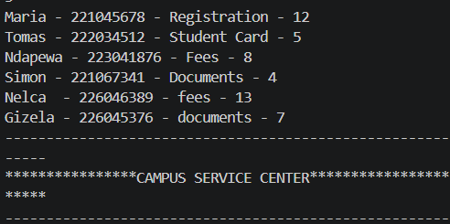

FRONT

SIMON
Student6
Student5

REAR

Linked List

A linked list is suitable because student records grow and shrink since one will enter and another will leave. Unlike an array, you don’t need to set a fixed size, you just update the list.

- INSERT.STUDENT(student)
newNode = create.node(student)
IF head == NULL:
head = newNode
ELSE
current = head
WHILE current.next != NULL:
current = current.next
current.next = newNode

- DISPLAY.STUDENTS():
current = head
WHILE current != NULL:
DISPLAY current.student.Name
DISPLAYcurrent.student.StudentNo
DISPLAYcurrent.student.ServiceType
DISPLAY
current.student.Estimated_Serv_Time
current = current.next

- CREATE new Node
Node.Student ← Student
Node.next ← NULL

END

- INSERTE STUDENT AT END
CREATE newNode
newNode.Student =Student
newNode.next =NULL
IF head = NULL THEN
head ← newNode
ELSE
current ← head
WHILE current.next ≠ NULL DO
current ← current.next
END WHILE
current.next ← newNode

END IF
END

- searchNode(studentNumber)
current ← head
WHILE current ≠ NULL DO
IF current.studentNumber = studentNumber THEN
DISPLAY "Student found"
DISPLAY current.data
RETURN
END IF
current ← current.next
END WHILE
DISPLAY "Student not found"

END
- INSERT AT SPECIFIC POSITION

START
Create newNode
newNode.student ← student
IF position = 1 THEN
newNode.next ← head
head ← newNode
ELSE
current ← head
FOR i ← 1 TO position - 2 DO
current ← current.next
END FOR
newNode.next ← current.next
current.next ← newNode
END IF

END

- deleteNode(studentNumber)
IF head = NULL THEN
DISPLAY "List is empty"
RETURN
END IF
IF head.studentNumber = studentNumber THEN
head ← head.next
RETURN
END IF

current ← head
WHILE current.next =! NULL AND current.next.studentNumber =! studentNumber DO
current ← current.next
END WHILE

IF current.next = NULL THEN
DISPLAY "Student not found"
RETURN
END IF
current.next ← current.next.next
END

- DIAGRAM
Inserting
Maria
Ndapewa
NUll
Simon
Tomas

- DIAGRAM
Deleting

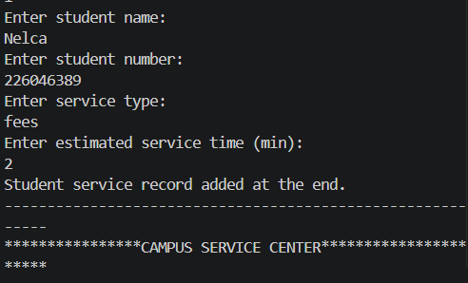
Insersion in the end

Insersion in the beginning

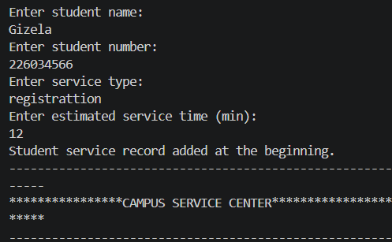

Display the records

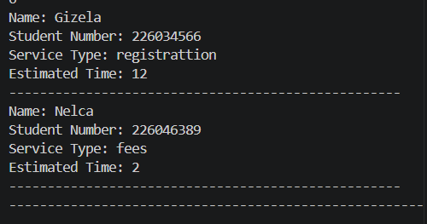

Delete the record

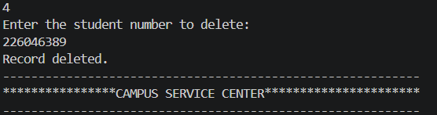

Insersion in the specific position

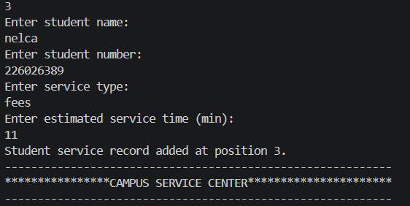

Search the record
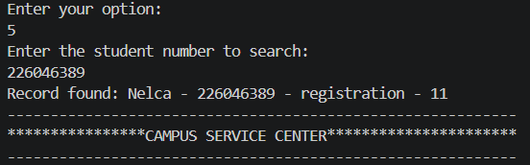

Stack

Stack is the appropriate structure since evaluations with fixed points depend on LIFO, operating with the most recent and always used first when an operator appears.

- Push

IF stack is full THEN
DISPLAY "Stack Overflow"
RETURN
END IF
top ← top + 1
stack[top] ← value

END

- pop()

IF top = -1 THEN
DISPLAY "Stack Underflow"
RETURN
END IF
value ← stack[top]
top ← top - 1

RETURN value
END

- peek()
IF top = -1 THEN
DISPLAY "Stack is empty"
RETURN
END IF
RETURN stack[top]

END

- evaluatePostfix

FOR each token in expression DO

IF token is a number THEN
push(token)

ELSE IF token is an operator THEN
operand2 ← pop()
operand1 ← pop()

IF token = "+" THEN
result ← operand1 + operand2

ELSE IF token = "-" THEN
result ← operand1 - operand2

ELSE IF token = "*" THEN
result ← operand1 * operand2

ELSE IF token = "/" THEN
result ← operand1 / operand2
END IF

push(result)

END IF

END FOR

result ← pop()

RETURN result

END

Symbol | Operation | Stack afther  (top bottom)
5 | Push(5) | [5]
3 | Push(3) | [5,3]
+ | Pop,pop,push(5+3) | [8]
2 | Push(2) | [2,8]
* | Pop,pop,push,push(8*2) | [16]

Step1-read ‘5’
Push(5)
5
TOP

Step2-read ‘3’
Push(3)
3
TOP
5

Ste3-read ‘+’
Pop()>3,pop()->
5+3 = 8,Push(8)
8
TOP

Step4-read ‘2’
Push(2)
2
TOP
2

Step5-read ‘*’
Pop()>2,pop()->8
8*2 = 16,Push(16)
16
TOP

Final result = 16

Justification of Structure

TaskA4- DAaily Stastics

Times[] – service times
4
8
5
12

CALCULATE_STATISTICS(times[], n):
total = 0
highest = times[0]
lowest = times[0]
countOver10 = 0

FOR i FROM 0 TO n-1:
total = total + times[i]
IF times[i] > highest:
highest = times[i]
IF times[i] < lowest:
lowest = times[i]
IF times[i] > 10:
countOver10 = countOver10 + 1

average = total / n

PRINT "Total students served: " + n
PRINT "Total service time: " + total
PRINT "Average service time: " + average
PRINT "Highest service time: " + highest
PRINT "Lowest service time: " + lowest
PRINT "Services over 10 min: " + countOver10

Student | Service Time
Maria | 12
Tomas | 5
Ndapewa | 8
Simon | 4

Stastics | Value
Total service time | 4
Total service time | 12+5+8+4=29
Average service time | 29/4=7.25
Highestservice time | 12(Maria)
Lowest service time | 4Simon()
Services over 10 min | 1(Maria only)

Array
selectionSort(array)

FOR i ← 0 TO length(array) - 2 DO

minIndex ← i

FOR j ← i + 1 TO length(array) - 1 DO

IF array[j] < array[minIndex] THEN
minIndex ← j
END IF

END FOR

SWAP array[i] WITH array[minIndex]

END FOR

END

insertionSort(array)

FOR i ← 1 TO length(array) - 1 DO

key ← array[i]
j ← i - 1

WHILE j >= 0 AND array[j] > key DO

array[j + 1] ← array[j]
j ← j - 1

END WHILE

array[j + 1] ← key

END FOR

END

mergeSort(array, left, right)

IF left < right THEN

middle ← (left + right) / 2

mergeSort(array, left, middle)

mergeSort(array, middle + 1, right)

merge(array, left, middle, right)

END IF

END

quickSort(array, low, high)

IF low < high THEN

pivotIndex ← partition(array, low, high)

quickSort(array, low, pivotIndex - 1)

quickSort(array, pivotIndex + 1, high)

END IF

END

Selection sort
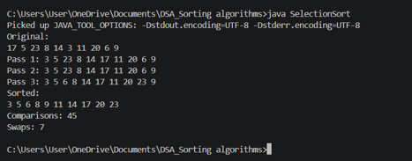

Insertation Sort
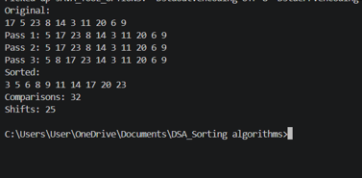
Merge Sort
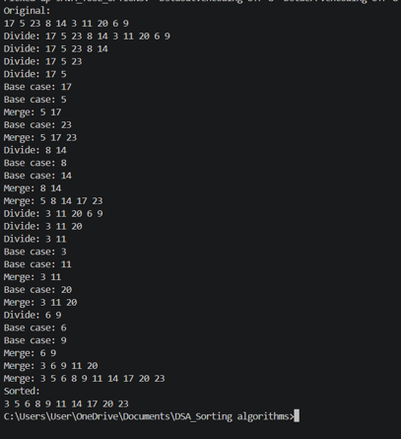
Quick Sort
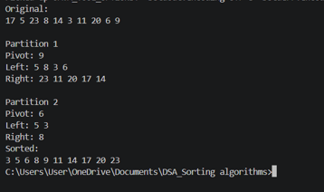
Selection Sort
Pass1 (comparison:9,swap:1
3
9
5
6
20
11
17
14
8
23

Pass2 (comparison:8,swap:0)
3
9
5
6
20
11
17
14
8
23

Pass3 (comparison:7,swap:1)
3
9
5
23
20
11
17
14
8
6

Pass | Comparisons | Swaps(this pass) | Comparisons(cumulative) | Swaps(cumulative)
1 | 9 | 1 | 9 | 1
2 | 8 | 0 | 17 | 1
3 | 7 | 1 | 24 | 2

Pass1 (comparison:1,swap:1)
5
9
17
6
20
11
3
14
8
23

Pass2 (comparison:1,swap:0)
5
9
17
6
20
11
3
14
8
23

Pass3 (comparison:3,swap:2)
5
9
8
6
20
11
3
14
23
17

Pass | Comparisons(this pass) | Shifts(this pass) | Comparisons  (cumulative) | Shifts(cumulative)
1 | 1 | 1 | 1 | 1
2 | 1 | 0 | 2 | 1
3 | 3 | 2 | 5 | 3

Divide Phase
[17,5,23,8,14,3,11,20,6,9]

[3,11,20,6,9]
[17,5,23,8,14]

[20,6,9]
[17,5]
[23,8,14]
[3,11]

[3]
[11]
[20]
[6,9]
[8,14]
[23]
[5]
[17]

[9]
[6]
[14]
[8]

Merge Phase
[3,5,6,8,9,11,14,17,20,23]

[3,6,9,11,20]
[5,8,14,17,23]

[6,9,9,20]
[5,17]
[8,14,23]
[3,11]

[3]
[11]
[20]
[6,9]
[8,14]
[23]
[5]
[17]

[14]
[9]
[6]
[8]

Quick Sort
Partitioning Stage 1
Before Partition 1 (pivot = last = 9)
17
9
5
6
20
11
3
14
8
23

Before Partition 1 (pivot 9-> index 4)
55
14
8
17
20
11
23
9
6
3

Pivot = 9 left partition = [5,8,3,6] right partion [23,11,20,17,14]

Partitioning Stage 2 left sub-array [5,8,3,6]
Partition2 – left sub-array(pivot=last=6)
6
3
8
5

Afther Parttion (pivot 6 -> index 2 ,within left sub-array)
8
6
3
5

Pivot = 6 left partition = [5,3] right partion [8]

PARTE C

Algorithm | Input Size | Number of Comparisons | Execution Time (ns)
SelectioSort | 20 | 190 | 15400
Insertion Sort | 20 | 93 | 40700
Merge Sort | 20 | 67 | 55800
Quick Sort | 20 | 109 | 40400
Selection Sort | 20 | 1225 | 305300
Insertion Sort | 50 | 556 | 57500
Merge Sort | 50 | 225 | 109800
Quick Sort | 50 | 369 | 53300
Selection Sort | 100 | 4950 | 409900
Insertion Sort | 100 | 2593 | 247100
Merge Sort | 100 | 548 | 479900
Quick Sort | 100 | 1007 | 200200
Selection Sort | 500 | 124750 | 3430300
Insertion Sort | 500 | 63979 | 7677000
Merge Sort | 500 | 3850 | 1736400
Quick Sort | 500 | 6710 | 674200

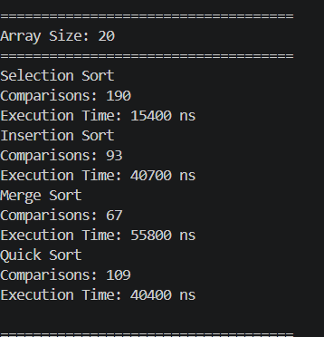
Array 20 elements

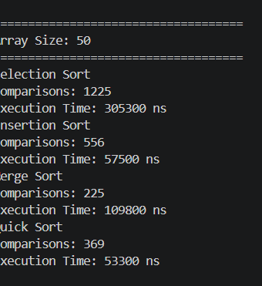
Array 50 elements
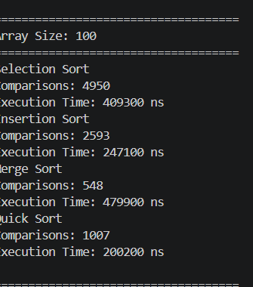
Array 100 elements

Algorithm | Number of Comparisons | Execution Time (ns)
Selection Sort | 4950 | 370100
Insertion Sort | 104 | 15200
Merge Sort | 357 | 121100
Quick Sort | 4643 | 351000

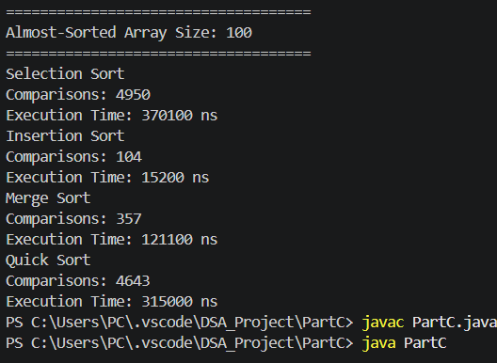
Almost sorted 100 elements

1. Which algorithm performed the fewest comparisons?

For the randomly generated arrays, Merge Sort performed the fewest comparisons for all four input sizes tested. It used 63 comparisons for 20 elements, 224 for 50 elements, 546 for 100 elements, and 3,851 for 500 elements. For the almost sorted 100 element array, Insertion Sort performed the fewest comparisons, with only 103 comparisons.

2. Which algorithm performed the most comparisons?

Selection Sort performed the most comparisons for all the input sizes tested. It used 190 comparisons for 20 elements, 1,225 for 50 elements, 4,950 for 100 elements, and 124,750 for 500 elements. It also used 4,950 comparisons on the almost-sorted 100 element array.

3. Which algorithm performed best on the almost-sorted array?

Insertion Sort performed particularly well on the almost-sorted 100 element array. It required only 103 comparisons and had an execution time of 19,200 ns. This is because Insertion Sort works efficiently when the data is already mostly sorted. Merge Sort used 357 comparisons, while Selection Sort and Quick Sort used 4,950 and 4,702 comparisons respectively.

4. Which algorithm appeared to scale best as the input size increased?
Merge Sort appeared to scale well as the input size increased. Its comparisons increased from 63 for 20 elements to 3,851 for 500 elements. This increase was much smaller than Selection Sort, which increased from 190 to 124,750 comparisons, and Insertion Sort, which increased from 125 to 60,610 comparisons. Quick Sort also scaled relatively well, increasing from 134 to 6,633 comparisons.

5. Did the results generally agree with the theoretical time complexity? Explain.

Yes, the results generally agreed with the theoretical time complexity. Selection Sort and Insertion Sort have O(n²) average/worst-case behaviour, so their number of comparisons increased rapidly as the input size increased. Merge Sort has O(n log n) time complexity, and its number of comparisons increased much more slowly. Quick Sort has an average time complexity of O(n log n), although its performance can depend on the choice of pivot. The measured execution times were not always perfectly consistent because they can be affected by the computer, Java runtime and other processes running on the system.

6. Is execution time alone enough to decide which algorithm is better? Explain.

No. Execution time alone is not enough to determine which algorithm is better. Execution time can vary depending on the computer, Java runtime and other processes running at the time of testing. Other factors should also be considered, such as the number of comparisons, theoretical time complexity, the condition of the input data, memory usage and whether the algorithm performs well on different types of input

Screenshot Menu Principal

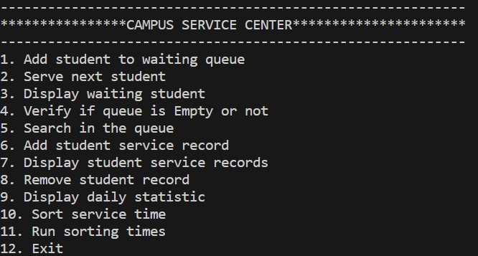

1.Screenshot Add student to waiting queue
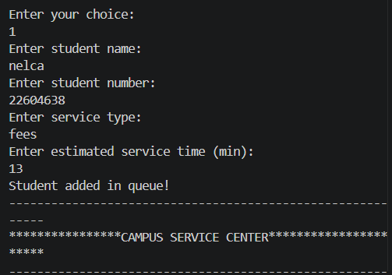

2.Screenshot Serve next student
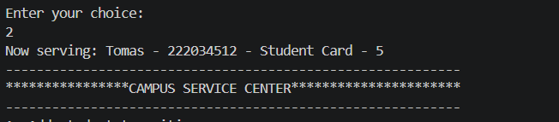

3.Screenshot Display the waiting list
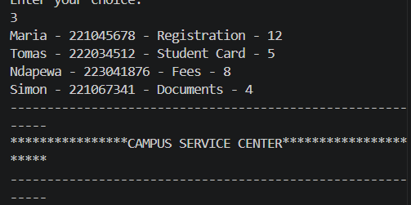

4.Screenshot Verify if the queue is empty

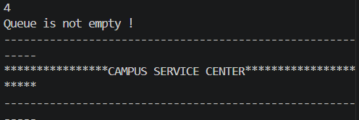

6.Screenshot Add student service record
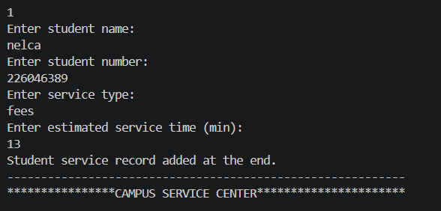

7.Screenshot Display student services
. 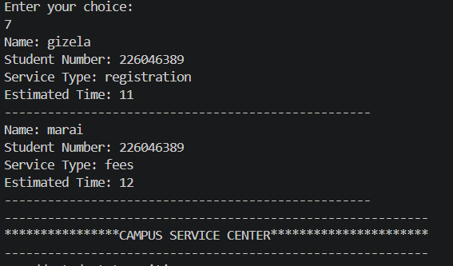

8.Screenshot Remove student record
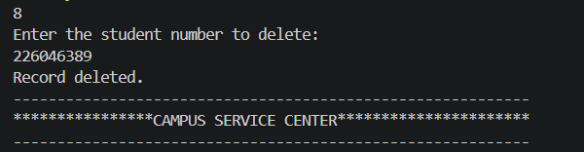

Link of the repository
https://github.com/226029522-Tafadzwa/DSA521S_GROUP_PROJECT_2026.git

